Nepal College of Information Technology
Unit Test
Fall 2009

Program: BE Time: 2 hrs
Semester: Fall FM: 50
Subject: Engineering Math-I PM:
Attempt ALL the questions. Figures at the margin indicate their full marks.

1. Evaluate the integral (any three) 5*3=15
a) 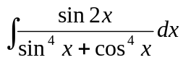 b) 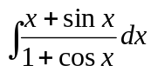
c) 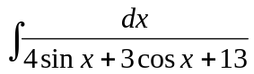 d) 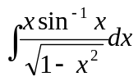

2. a) Evaluate 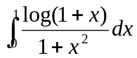 8
b) Evaluate 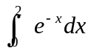 by summation method 7

3. a) Find the area bounded by the curve y = x² + 1 and the line y = -x + 3. 7
b) Find the volume of the solid in the region in the first quadrant evolved by the parabola y = x², the y - axis and the line y = 1 revolved about the line x = -1. 8

4. a) Show that the entire length of the asteroid 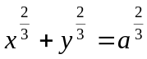 is 6a. 7
b) Use Trapewidal and Simpson's rule with n = 4 to approximate the area between the curve y = x² + 1 ordinates at x = 1, x = 5 and x- axis and compare the results with exact value. 8
Nepal College of Information Technology
Unit Test
Fall 2009

Program: BE Time: 2 hrs
Semester: Fall FM: 50
Subject: Engineering Math-I PM:
Attempt ALL the questions. Figures at the margin indicate their full marks.

1. Evaluate the integral (any three) 5*3=15
a) b)
c) d)

2. a) Evaluate 8
b) Evaluate by summation method 7

3. a) Find the area bounded by the curve y = x² + 1 and the line y = -x + 3. 7
b) Find the volume of the solid in the region in the first quadrant evolved by the parabola y = x², the y - axis and the line y = 1 revolved about the line x = -1. 8

4. a) Show that the entire length of the asteroid is 6a. 7
b) Use Trapewidal and Simpson's rule with n = 4 to approximate the area between the curve y = x² + 1 ordinates at x = 1, x = 5 and x- axis and compare the results with exact value. 8

